# RAP-BUSINESS Object-Association Vs Composition-v2-RAP Architecture

<https://youtu.be/zq0e-Dbn3LY?list=PLqz8SLrkjv2iwPtPRJ4V6zJRfgNrgZKlQ>

1. What is BO?
2. What is Compositions?
3. What is the difference bw composition vs Associations?

# RAP- Architecture

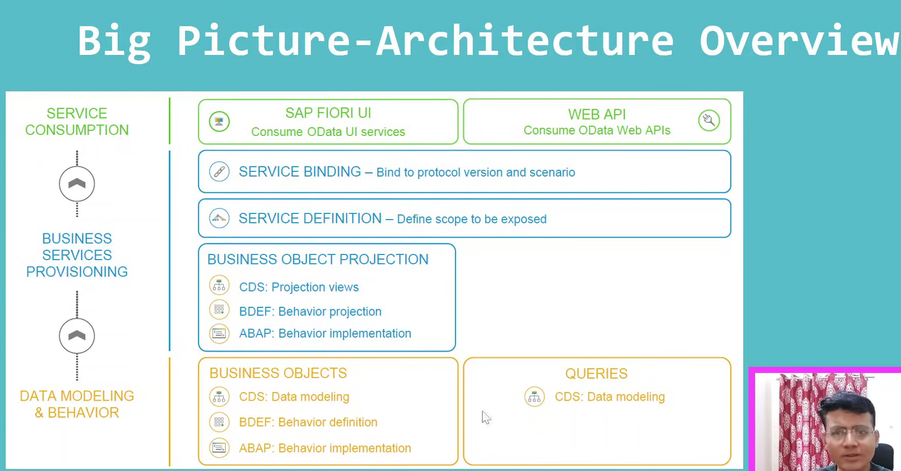

What is API and Web API?- Odata services videos

In RAP- we have three parts.

1. Data Modeling & Behavior.
2. Business service and Provisioning
3. Service consumption

## Data modeling and Behavior:

1. Define data model- What all are the data, we will fetch the data from different tables and create the data model.
2. Not only data model, we will define that how data model will be consumed. Means you can do CRUD operations and what all are the actions you can take those are we can define here.

## Business Service- Provisioning:

1. What part of data model will consume, we will define.
2. What is the consumption, what all are the protocol to used means we want to create Odata v4 service/ v2 service and what purpose we are creating the service? We want create the service for the web APIs/Fiori Apps.

Above all are come under second part.

## Service Consumption:

1. Where we will actually consuming the service, either in Fiori or WEB API.

# Task-1- Defining Data model and Behavior- Data model – Business Object

Data modeling and Behavior:

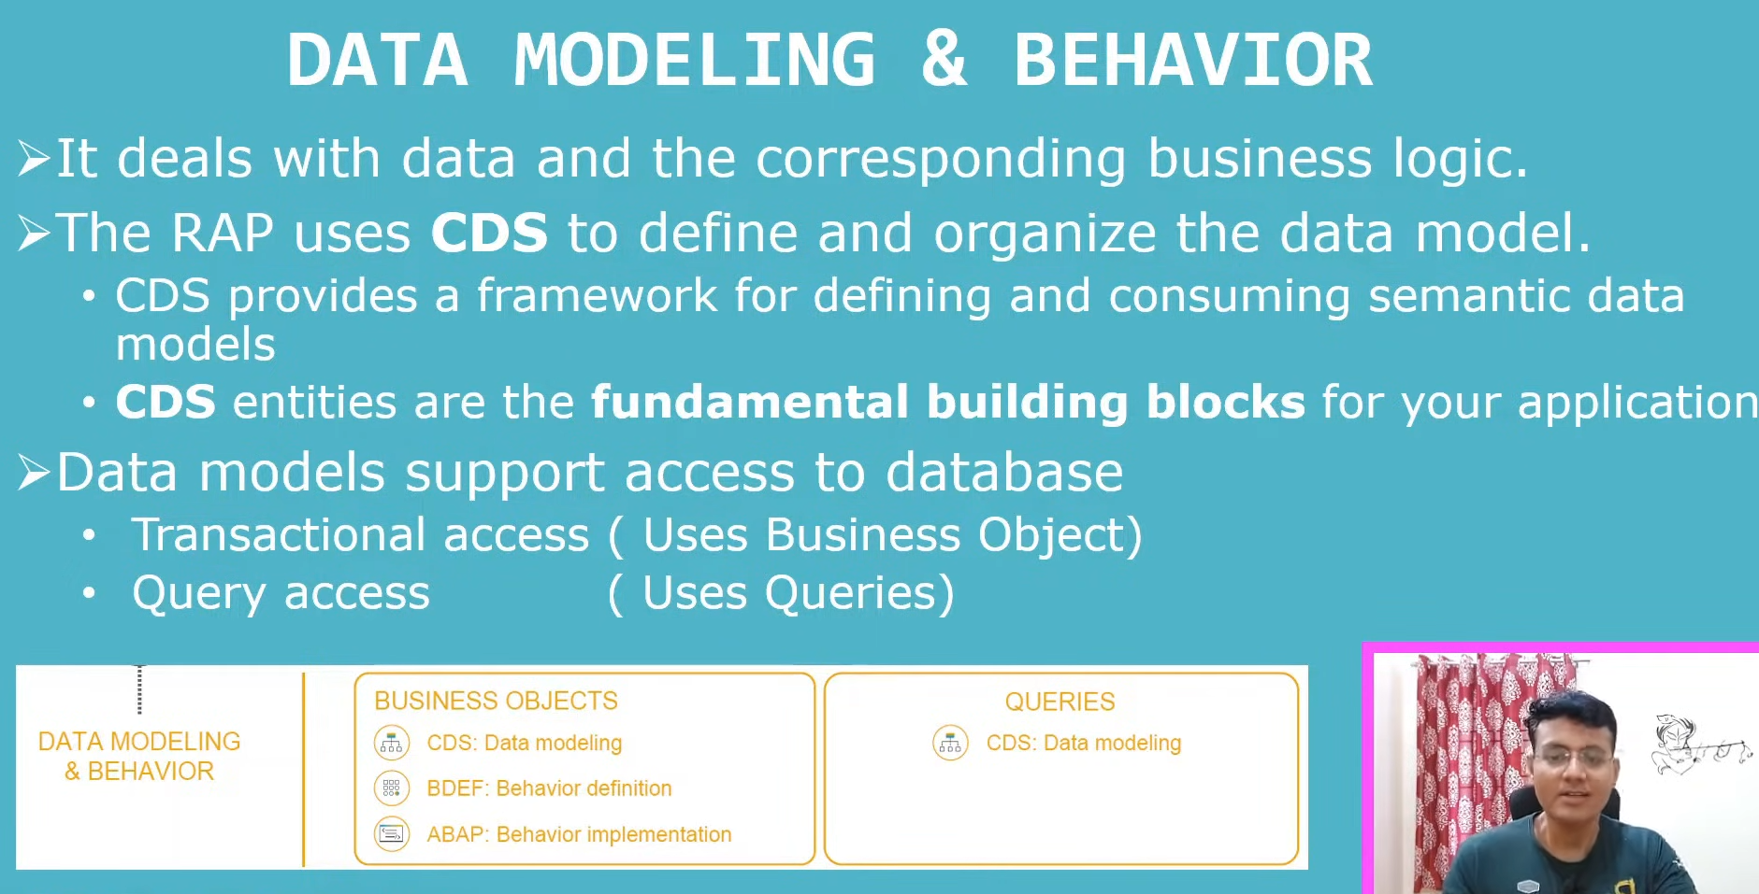

1. CDS is the fundamental building block of creating RAP app.
2. RAP is the framework to define and consume the sematic data models.
3. Data model access the data from Data bases.
4. For Query access- required CDS- Data modeling only.
5. For transactional access- we need the Business Objects. Here we will define the behavior definition and implementation using ABAP language.

Behavior Implementation

|

Behavior Definition

|

Data model – CDS

## What is Business Object?

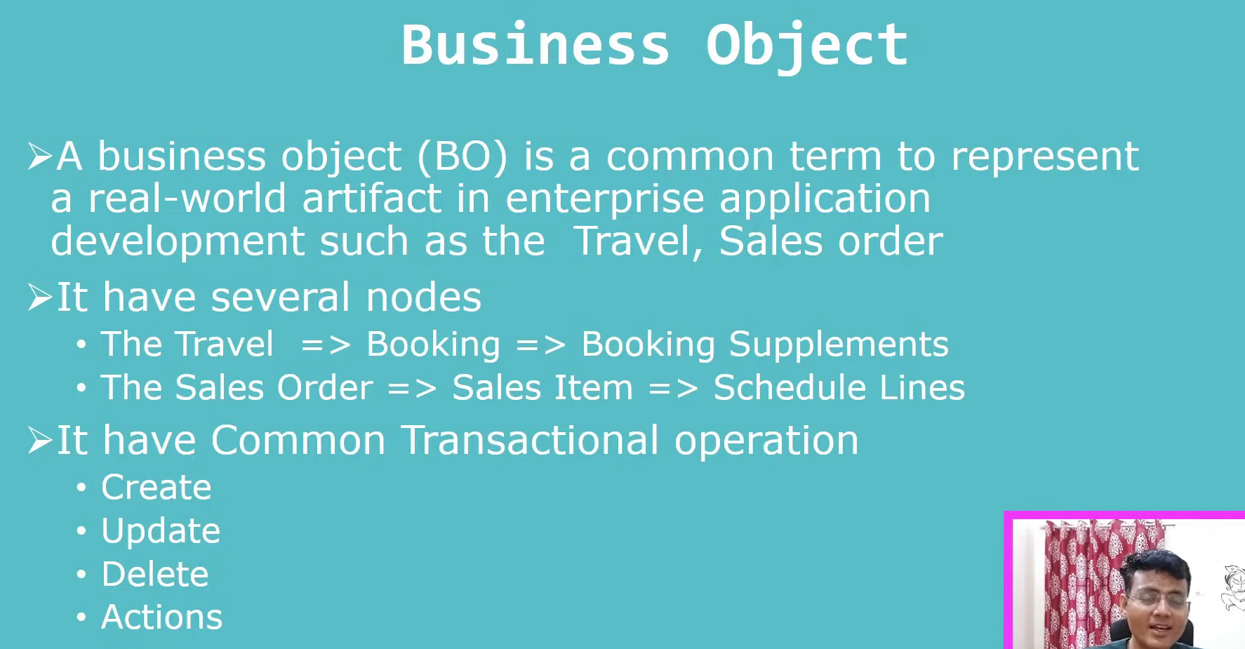 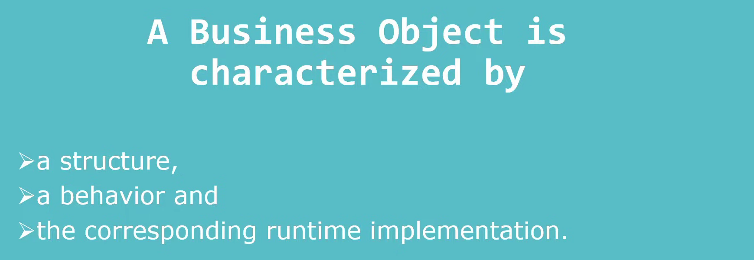 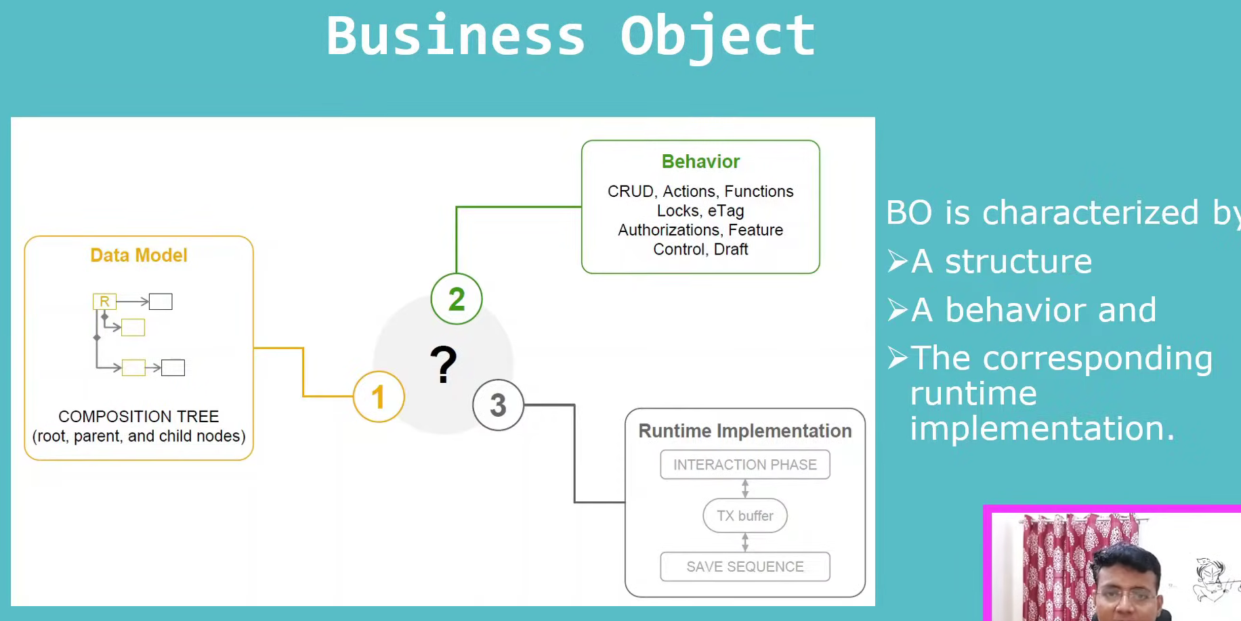 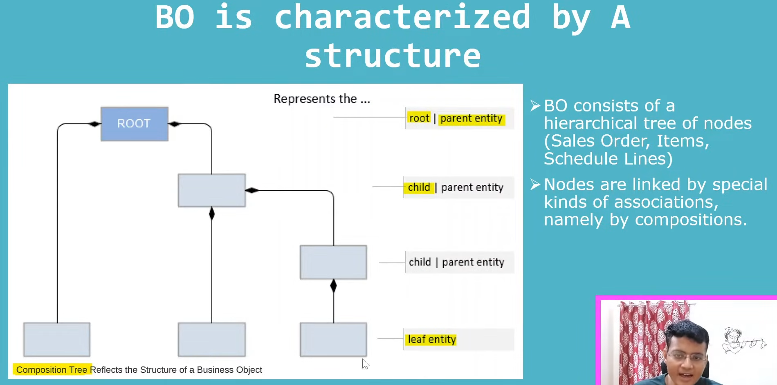

## Association VS Composition

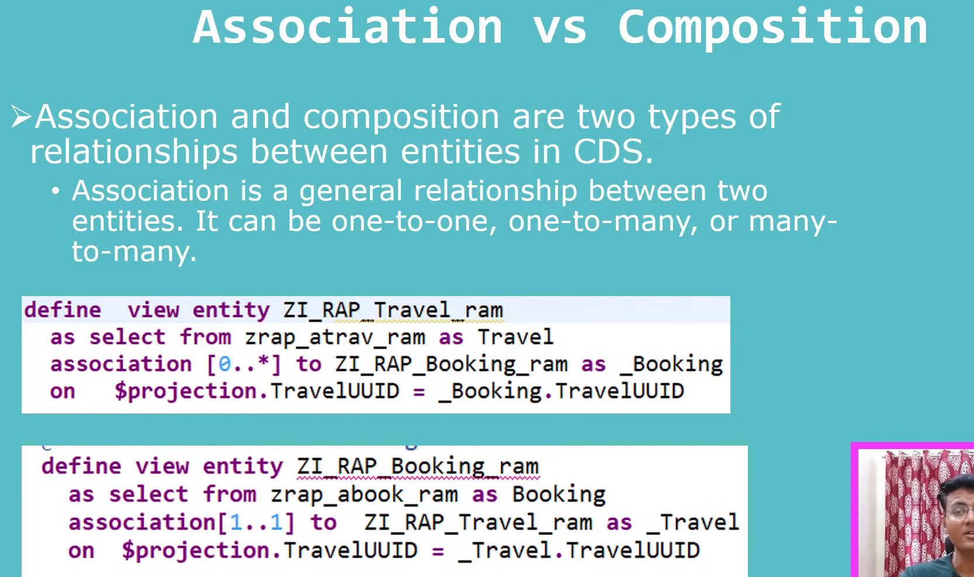

1. Association is loose relationship and composition is tight relationship.
2. Ex: Sales order and sales order Item, one sales order line item can’t exist without the sales order, so that relationship is not the loose relationship and that is the strong relationship, this is not possible to define through the associations, for this we can use the compositions.

### What is composition?

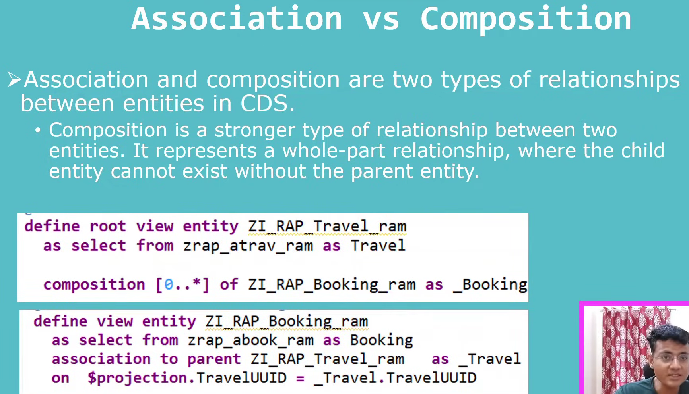

Travel(Composition) – Booking( Association)

Defining composition.: composition select from data is parent entity.

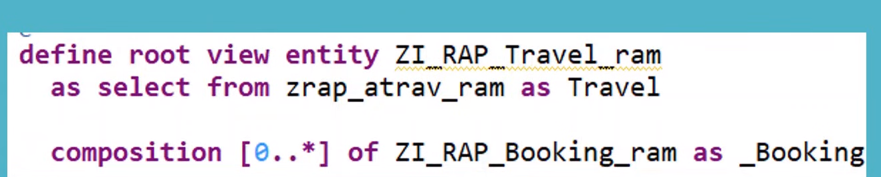

1. Use the select from parent entity
2. Use the composition
3. Use the cardinality to the child entity
4. Not required the condition. When you define the child entity we have to tell the composition.

Child entity definition:

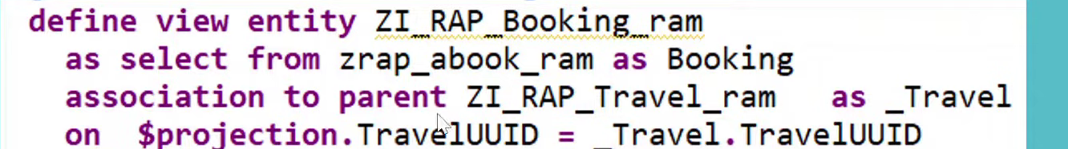

1. Select from booking entity.
2. Booking enity is association to the parent- travel(composition)
3. Use the condtion in child entity.

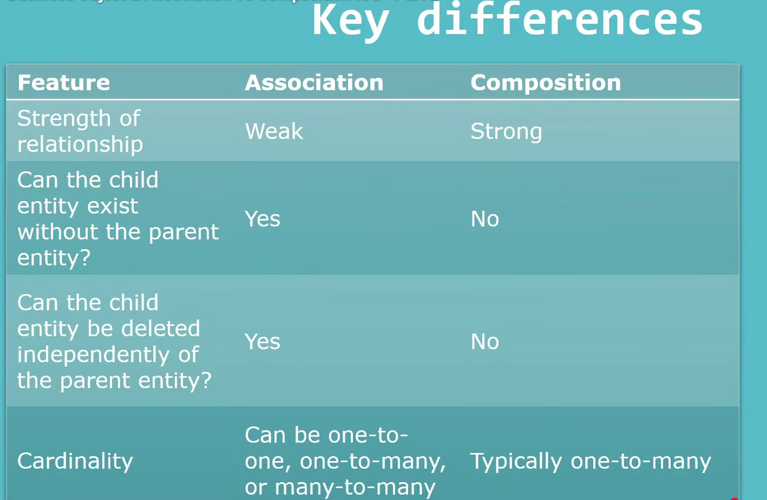

When to use the association and compositions?

Ex:1 – sales order header and line item -between composition. Means- sales order line item not possible to exist with out sales order header data. Here we use the composition.

While deleting: the sales order header, corresponding records of line item also deleted. In composition.

Ex:2- Sales order vs material- here material exist with out sales order, in this case we can go with the associations.

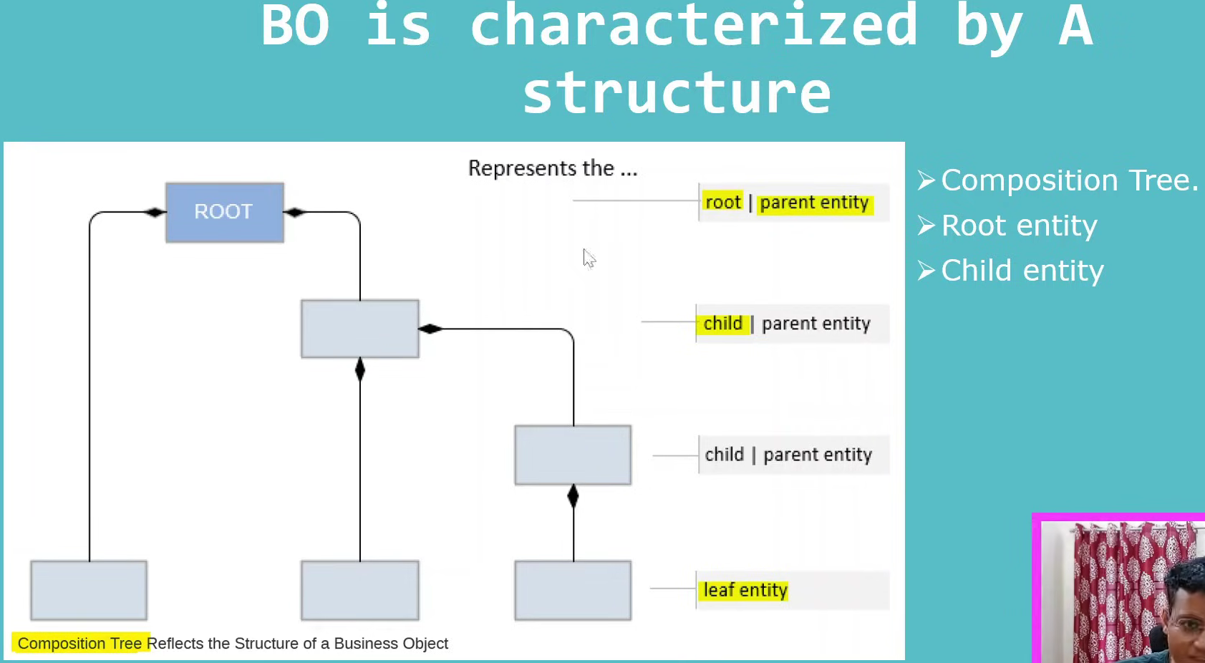

## What is the root entity/node?

